**STEERING CONCEPTION**

# Goals

* Optimize tires grip in cornering.
* Offer satisfying driving experience regarding the steering wheel effort feedback.

# Conception

## Step 1: Determination of the optimum wheel angle thanks to a cornering model

**Hypothesis:**

* The tires are working at their maximum potential
* The car is cornering in steady state
* The camber change and tire pressure variation is not taken into account
* The center of gravity is estimated at 0.3m.

Figure 1: Determination of the best angle difference to maximise grip

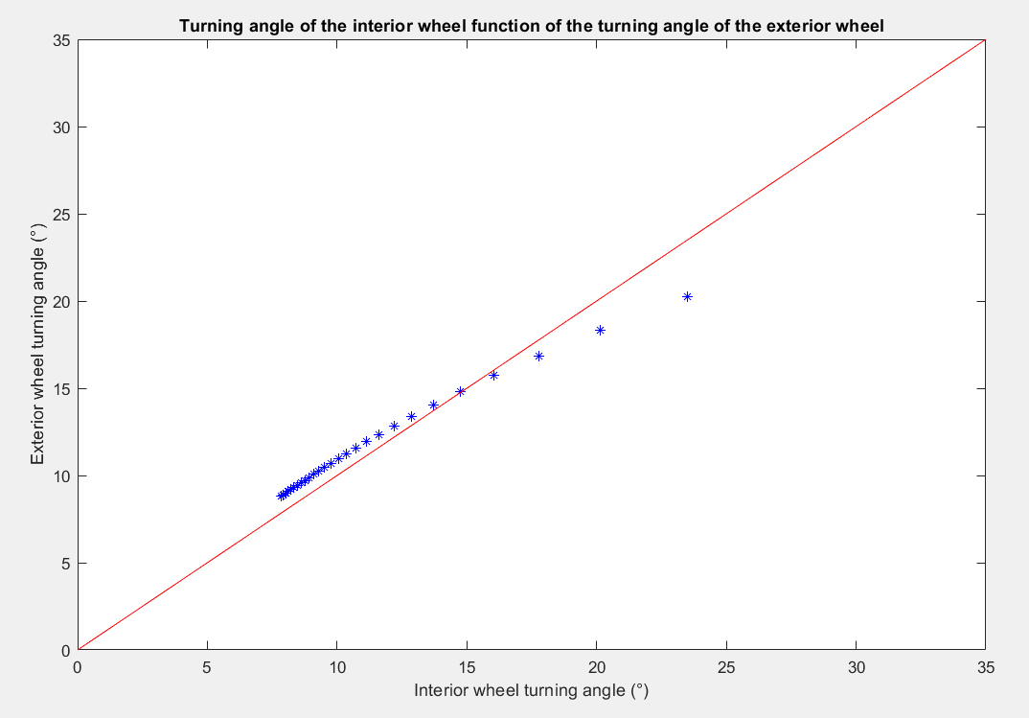

**Anti-Ackerman :**

High speed cornering in large corner.

**Ackerman :**

Low speed cornering in

tight corner.

**Skidpad**

The model gives a velocity of 12.4 m/s in skidpad hence a time of 4.9s.

## Step 2: Determination with a 2D model of the real geometry fitting theoretical data

## 

Figure 2: Geogebra model, top view of the steering geometry

## 

Figure 3: Comparison between the 2D geometry and the theory

* Choice of an Ackerman type geometry to favour the skidpad

## Step 3: Validation of the geometry

Figure 4: Validation of the geometry with a 3D model (Catia) and reality (geometry bench)

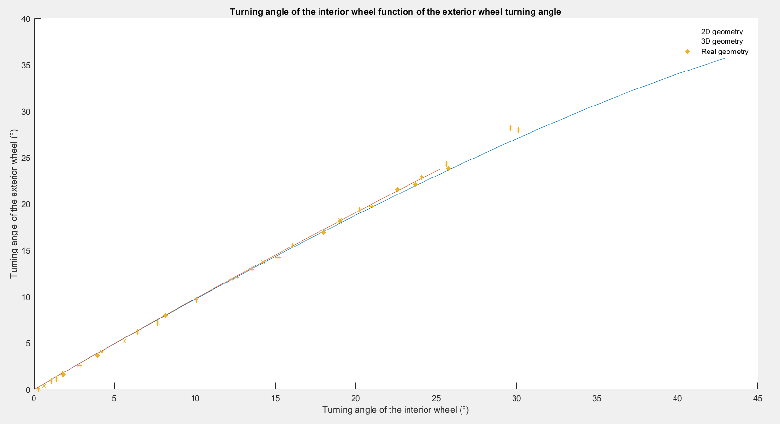

## Step 4: Validation of the geometry

## 

Figure 5: 2D model to minimize bump steer

## Step 5: Castor trail determination

## 

Figure 6: Tyre data study to determine the castor trail giving the maximum of grip at the maximum of self-aligning torque

* The ideal castor trail is highly dependent on the tyre load and pressure, hence it was decided to only use the castor trail to tune the effort in the steering wheel.

## Step 6: Steering wheel effort feedback adjustment

The strength on the steering wheel was determined with a static model, the target value of 11.5N at 0° of input angle was chosen with the team experience.

**Hypothesis:**

* U-Joint efficiency of 1
* Static load case on the tyre
* No lateral forces on the tyre

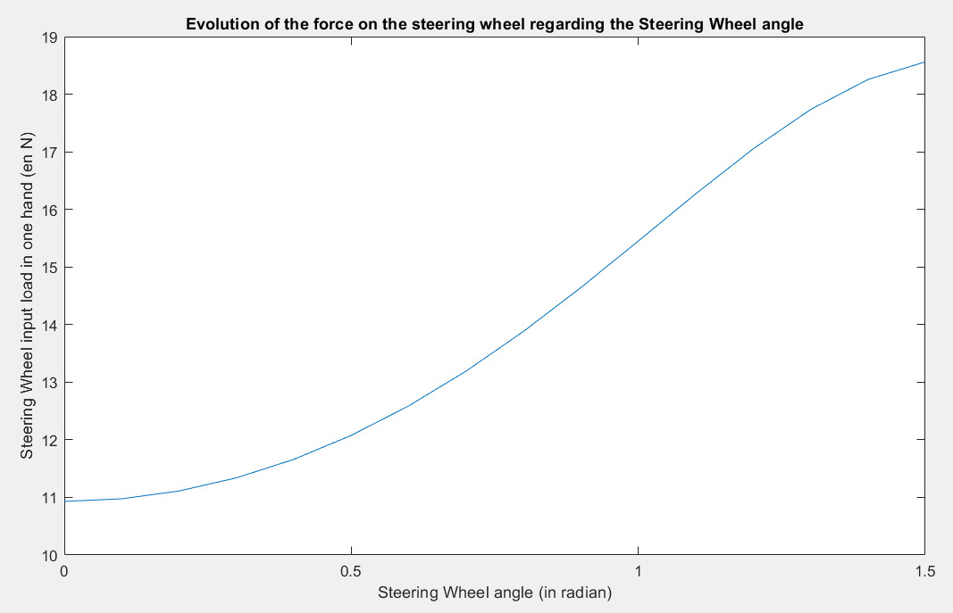

Figure 7: Model helping to choose the proper castor trail based on driver feedback on previous vehicle

## Step 7: 3D conception

For the 3D conception, the load cases were:

* **100 N.m** of torque in the steering wheel
* **660N** of vertical load on the steering wheel
* **560N** of axial load on the steering linkage.